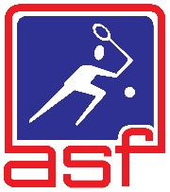
An ASF Asian Junior Super Series
DIAMOND EVENT

MILO ALL STAR MALAYSIA SQUASH JUNIOR OPEN 2026
Asia’s Rising Stars Collide in Kuala Lumpur!

📅 13 – 18 OCTOBER 2026
This isn't just another tournament. It's your moment. Welcome to the Milo All Star Malaysia Junior Open 2026, a prestigious DIAMOND EVENT on the Asian Junior Super Series. For six days in October, the future of squash will be decided on Malaysian soil, as the next generation of champions battles for glory, ranking points, and a place in the history books.

THE BATTLEGROUNDS
The championship will take over three premier venues in the heart of Kuala Lumpur, ensuring a world-class experience for players and spectators alike:
• 🏟️ Pusat Skuasy Jalan Duta
• 🏟️ Astaka Squash Centre
• 🏟️ Universiti Malaya (standby)

THE CHALLENGES: 10 TITLES, ONE LEGACY
Every player enters one event, guaranteed at least two matches, with the tournament team working tirelessly to maximize game time for all participants. Choose your age group and claim your crown:
Boys Girls
🏆 Under 19 Open Championship 🏆 Under 19 Open Championship
🏆 Under 17 Open Championship 🏆 Under 17 Open Championship
🏆 Under 15 Open Championship 🏆 Under 15 Open Championship
🏆 Under 13 Open Championship 🏆 Under 13 Open Championship
🏆 Under 11 Open Championship 🏆 Under 11 Open Championship

KEY DATES & DEADLINES
• Age Cut-Off Date: 18th October 2026. Your age on this date determines your age group.
• Entry Deadline: 5.00pm (Malaysian time) 14th September 2026. Strictly enforced—no late entries will be accepted.

ENTRY & ELIGIBILITY
Who Can Play?
The tournament is open to all local and international players who are not under suspension by SRAM or the ASF.
Key Requirements for All Players:
- WSF SPIN Registration: Every competitor, in all age groups, must have a valid WSF SPIN number. Secure yours now at www.worldsquash.org/spin.
- Endorsement: Foreign entries must be endorsed by their respective National Association or Federation.
- Identification: All Malaysian players must provide their I/C number; all overseas players must provide their passport number. Please ensure accuracy—passport verification may be conducted.

ENTRY FEES & PAYMENT
Pay to Play (Entry Fee Excludes Accommodation):
- Foreign Players: USD 140.00
- Local Outstation Players: RM 140.00 (Malaysian passport/ID card holders only)
Payment Method:
- All payments must be made via Telegraphic Transfer (Bank TT) to SRAM.
- Name of Bank Account PERSATUAN SQUASH MALAYSIA
- Bank Account Number : 8600134016
- Name of Bank : CIMB Bank
- Swift Code : CTBBMYKL
- Important: An additional USD 20 is required per transaction to cover bank charges.
- Complete your entry: Submit your official entry form along with the payment slip to tournaments.sram@gmail.com.
- Cheques and bank drafts are not accepted.

ACCOMMODATION
Please be advised that accommodation will not be provided by the organizers. However, we recommend Hotel Dorsett Hartamas Kuala Lumpur as a convenient option for your stay. The hotel is offering an exclusive discount for reservations made for this tournament. We encourage you to book early to secure the rate. Complimentary transportation to Squash Centre Jalan Duta will be provided by the hotel for guests who book using the special tournament discount(Subject on availability). Please use voucher code “SRAM” during reservations to enjoy exclusive deal from Hotel Dorsett Hartamas Kuala Lumpur.
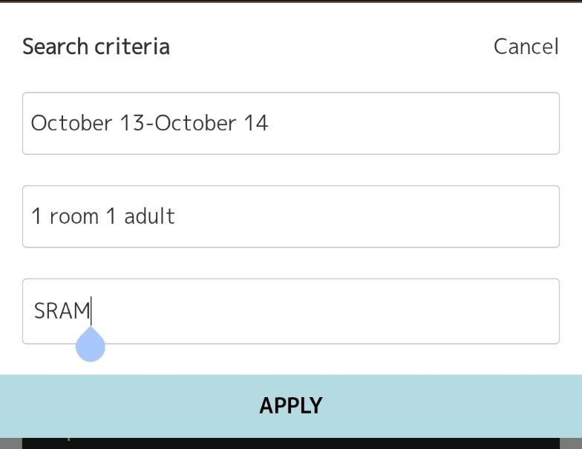

PLAYER WITHDRAWAL POLICY
- Any withdrawal from the Championship must be notified to SRAM as soon as possible by email. Anyone wishing to pay entry fees upon arrival will still be required to pay the entry fee even if he or she withdraws before the start of the tournament. Failing to pay the entry fee will result in the player being banned from this event in future until the fees owing is paid up.

- PAID UP ENTRY WILL NOT BE REFUNDED. Paid up entry fee is not transferable from one player to another player in the event of a pull out.
- Late Withdrawal after the closing date will be considered ‘late withdrawal’. All late withdrawals must be accompanied with a medical certificate or with relevant documents supporting valid reasons. Failure to do either will result in the player scoring ‘zero’ ranking points. The ‘zero’ ranking points will be reflected as one of the player’s 4 best results. For those who produce the relevant documents, ASF will evaluate each withdrawal on a case-to-case basis.
TOURNAMENT GEAR & BALL
• Official Ball: Dunlop Revelation Pro Squash Ball.
• Apparel: All participants will receive one official tournament T-shirt.

TRANSPORTATION
- Shuttle services are provided exclusively for players booking the Hotel Dorsett Hartamas
- Kuala Lumpur package. (8.00am and 2.00pm only)
- Important: Shuttles run only on tournament days (13-18 Oct) to Jalan Duta Squash Centre only. (Subject on availability)
- First come first serve basis.
- Limited space and those missing the complimentary shuttle will have to organise their own ride

RANKINGS & SEEDINGS
Players are strongly encouraged to include their ASF (AJSS) and national rankings in their entry forms. Seeding for the tournament will be based on the latest AJSS rankings available.

PRIZES
- Trophy, Medal and Milo products for Top 8 all categories
- 1 night hotel stay voucher at Hotel Dorsett Hartamas for Champion all categories
- Prize money for U17 & U19 (Top 4)
- Dunlop merchandises for Top 4 all categories

TOURNAMENT ORGANISATION
• Organizer: Squash Rackets Association of Malaysia (SRAM)
Championship Director – Mr. Nafzahizam Adnan
Championship Referee – Mr. Francis Gan
Treasurer/Finance – Siti Naizaratulnisak Mahmud
Tournament Secretariat – Naim Bashah, Afiq Ismail
• Sanctioning Body: Asian Squash Federation (ASF) – This event is part of the Asian Junior Super Series.
• For more information on the series, visit the ASF website: www.asiansquash.com.
Are you ready to make your mark? Enter the Milo All Star Malaysia Junior Open 2026 and prove you belong among Asia's best. The courts are waiting, the crowd is watching—see you in Kuala Lumpur!

RULES AND REGULATIONS
- All officials and players must arrive at venue at least 15 minutes before their matches start.
- All players MUST check their next round matches before leaving the venue.
- Walkover will be given, if the player is late by 15 minutes at the time the name is called.
- All players must mark and referee matches when required.
- All players must wear eyewear.
- The matches are based on circuit format. Winners of all rounds will play best of five. Loser will be best of 3. Top 16 positions will play best of 5 until the final positions.
- The scoring format is 11 Points – PAR (Point-A-Rally) and following the WSF Rules of World Singles Game.
- The Organizing Committee reserves the rights to make changes to the format of play (if necessary) after the entry closes. The decisions shall be final.
- All players must play their respective matches as per the tournament draw. The organiser is not obliged to make any changes to match times as per schedule.
- All late withdrawals must be accompanied with a medical certificate or with relevant documents supporting valid reasons.
- Failure to do either will result in the player scoring ‘zero’ ranking points. The ‘zero’ ranking points will be reflected as one of the player’s 4 best results. For those who produce the relevant documents, ASF will evaluate each withdrawal on a case-to-case basis.

