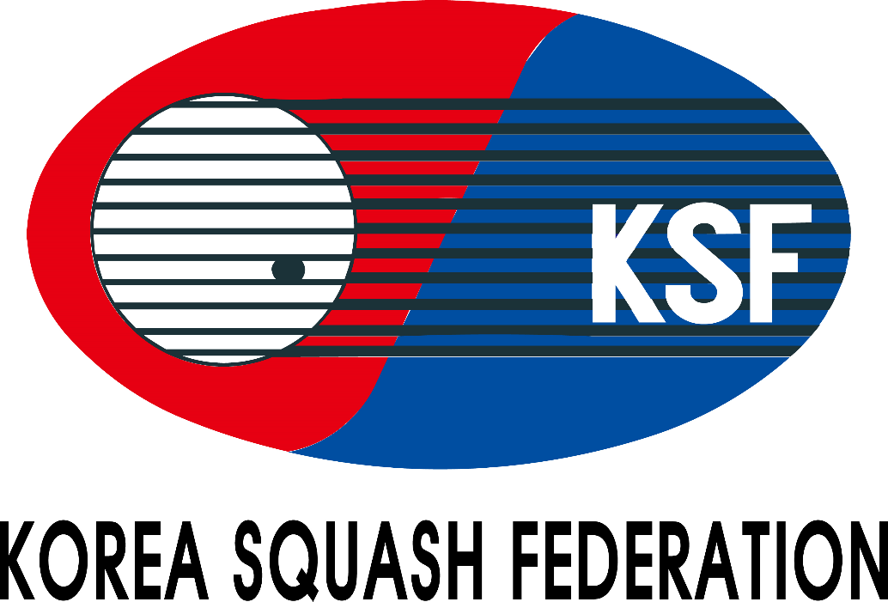

Championship Handbook
Korea Cup Junior Open Squash Championships(Silver)
(8th – 12nd February 2026)

Venue:
GimcheonSquash Stadium

Organized by
Korea Squash Federation
Gyeongsangbuk-do Squash Federation
Gimcheon-si



KOREA CUP JUNIOR OPEN SQUASH CHAMPIONSHIPS 2026
TOURNAMENT INFORMATION

VENUE
Stadium: Gimcheon Squash Stadium, 1 Undongjang-gil, Gimcheon-si, Gyeongsangbuk-do, South Korea

DATE
8th -12nd February 2026 / 5days
EVENTS
1. Boys under 11 Open Event 1. Girls under 11 Open Event
2. Boys under 13 Open Event 2. Girls under 13 Open Event
3. Boys under 15 Open Event 3. Girls under 15 Open Event
4. Boys under 17 Open Event 4. Girls under 17 Open Event
5. Boys under 19 Open Event 5. Girls under 19 Open Event

AGE CUT OFF DATE
* The age cut off date for the Championships is 12 February 2026
Age categories may be combined due to low entry levels at the discretion of the organizer.
If age categories are combined, participants will receive ranking points for the higher age category played.

ENTRY FEES
- Shuttle bus and Hotel packages will not provided.
- No airport pick-up service will be provided.
- Foreign Player: USD 80 per person
- Local player: KRW 50,000 per person

RECOMMENDED HOTEL
Hotel : Logenir Hotel
Address: 16, hyuksin 3-ro, Gimcheon-si, Gyeonsangbuk-do, South Korea
Tel: +82-54-429-4700
Email: logenir@logenir.com
Web Site: http://www.logenir.com/

ELIGIBILITY
1) Registered players of the Korea Squash Federation in 2026
2) Players of member countries of the World Squash Federation
3) Resident aliens in Korea
4) Members of the squash club
* Juniors entries without SPIN number will be rejected

ENTRY SUBMISSION
1) Applications for the entry submission must be applied by players through “Forwarding the entry form” to the KSF
e-mail : koreasquash@sports.or.kr / CC:dlwkdgo94@naver.com, kbsquash@naver.com
* All foreign player entries must be endorsed by their respective National Squash Federation
2) Closing Date: 20th January 2026 at Korea time 6:00pm (Late entries will not be accepted)
3) Entry Fee Payment : The payment must be paid in CASH to the KSF Office upon arrival.(Only USD)
4) Drawing for List of Matches : 23rd January 2026 at Korea time 2:00pm, the KSF Office
* Time of the drawing may be subject to change

RULES
1) Match Play: 5 games, 11 points - PAR (Point-A-Rally) through the tournament
2) Match Rules: The Championship will be run in accordance with the ASF Championship Regulations
3) Game Balls: Dunlop XX Championship ball

AWARD
1) No.1/2/3 in Boys & Girls under 11, 13, 15, 17 and 19 competition – A medal
2) No.1/2 in Boys & Girls under 11, 13, 15, 17 and 19 Plate
* All players will have at least 2matchs / including plate games
* The special and classical plate games will be announced after all the matches are released. > If not duly the number of players,
this game may not be held.

TOURNAMENT OFFERS
1) A championship souvenir T-shirt (including Coaches and Managers)
2) Water beverages

OTHERS
1) For more information, please contact to the Korea Squash Federation.
2) All players must comply with the ASF regulations of entry including any rules with regard to clothing
(Disqualified if violation occurs)
3) All Players must wear the T-shirt showing name of the team and the player
4) All juniors under 19 years must wear protective glasses
5) Players & Officials should check with the Embassy of the Republic of Korea to verify the need for a visa
6) Please send us passports.

Form A
Korea Cup Junior Open Squash Championships 2026 Entry Form
Gimcheon Squash Stadium(1 Undongjang-gil, Gimcheon-si, Gyeongsangbuk-do)

Country:
No | Name in BLOCK LETTER |  | Date of Birth  dd/mm/yy | B/G | SPIN Number | Age  Category | ASF Ranking | Current National  Ranking / world  Ranking | T-Shirt  Size | Results / Achievements in major international championships (2025 / 26)
No | Surname | First Name
1 |  |  |  |  |  |  |  | / | Ex)S,M,L,XL...
2 |  |  |  |  |  |  |  | /
3 |  |  |  |  |  |  |  | /
4 |  |  |  |  |  |  |  | /
5 |  |  |  |  |  |  |  | /

Manager: |  |  | Coach:

Entry Fee (Foreign) |  | X USD80 |  |  | USD
Entry Fee (Local) |  | X 50,000Won |  |  | Won
Total:
*No shuttle services
*No airport pickups will be provided
Endorsement by the National Federation
On behalf of _________________ (Name of Federation), I hereby confirm that we endorse this entry for Korea Cup Open 2026.
Name |  | Position
Date |  | Signature |  | Federation Chop
*Please forward the completed entry form to:
Korea Squash Federation email: koreasquash@sports.or.kr by 20th January 2026.
CC: dlwkdgo94@naver.com , kbsquash@naver.com

📢 Transportation Information
Incheon International Airport (ICN) → Gimcheon Squash Stadium
Departure: Incheon International Airport (ICN)
Destination: Gimcheon Squash Stadium
(Gimcheon Sports Complex, 1 Undongjang-gil, Gimcheon-si, Gyeongsangbuk-do)

🚌 Express Bus & Taxi
Route: Incheon International Airport → Gimcheon Bugok Airport Bus Stop → Gimcheon Squash Stadium

1. Incheon International Airport → Gimcheon Bugok Airport Bus Stop
(Travel time: approximately 4 hours)
- Bus schedule (as of January): Weekdays / Weekends: 08:30 / 11:50 / 15:00 / 18:00
(Operates 4 times daily)

2. Gimcheon Bugok Airport Bus Stop → Gimcheon Squash Stadium
- By taxi(Travel time: approximately 10 minutes)

📢 Transportation Information
Daegu International Airport → Gimcheon Squash Stadium
Departure: Daegu International Airport
Destination: Gimcheon Squash Stadium
(Gimcheon Sports Complex, 1 Undongjang-gil, Gimcheon-si, Gyeongsangbuk-do)

🚆 Train & Taxi
Route: Daegu International Airport → Dongdaegu Station → Gimcheon Station / Gimcheon-Gumi Station → Gimcheon Squash Stadium
1. Daegu International Airport → Dongdaegu Station
- By taxi or local bus(Travel time: approximately 15–20 minutes)
2. Dongdaegu Station → Gimcheon Station or Gimcheon-Gumi Station
- By KTX or regular train(Travel time: approximately 25–50 minutes)
3. Gimcheon Station / Gimcheon-Gumi Station → Gimcheon Squash Stadium
- By taxi(Travel time: approximately 10–15 minutes)
4. (Alternative – Steps 2 & 3 skipped) Dongdaegu Station → Gimcheon Squash Stadium
- By taxi(Travel time: approximately 1 hour)

🚖 Private Car / Taxi
Travel time: approximately 50–60 minutes(Subject to traffic conditions)
* Recommended for group travel or passengers with large luggage

