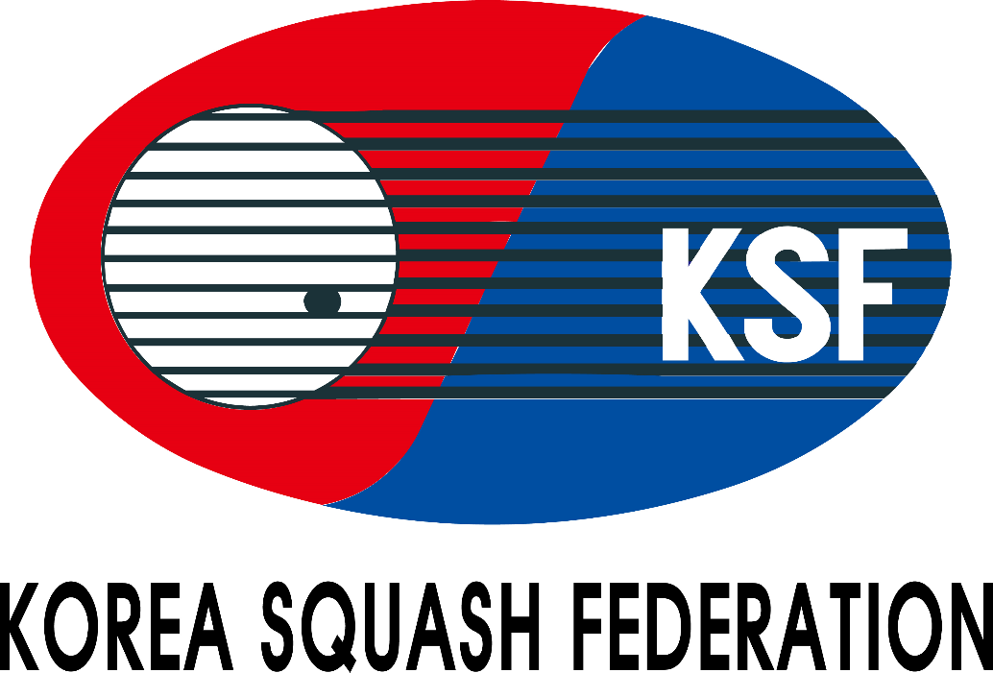

Championship Handbook
The 18th Korea Junior Open 2025(Gold)
(18th – 21st AUGUST 2025)

Venue:
Incheon Yeorumul Squash Stadium

Organized by
Korea Squash Federation

Supervision by
Incheon Squash Federation

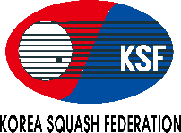
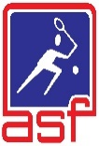
The 18th Korea Junior Open 2025
TOURNAMENT INFORMATION

VENUE
Hotel: Ramada Hotel, 29 Neungheodae-ro 267beon-gil, Yeonsu-gu, Incheon, South Korea
Stadium: Incheon Yeorumul Squash Stadium (164, Yeorumul-ro, Bupyeong-gu, Incheon, Republic of Korea)
DATE
18th – 21st August 2025 / 4days
EVENTS
1. Boys under 11 Open Event 1. Girls under 11 Open Event
2. Boys under 13 Open Event 2. Girls under 13 Open Event
3. Boys under 15 Open Event 3. Girls under 15 Open Event
4. Boys under 17 Open Event 4. Girls under 17 Open Event
5. Boys under 19 Open Event 5. Girls under 19 Open Event

AGE CUT OFF DATE
* The age cut off date for the Championships is 21th August 2025
Age categories may be combined due to low entry levels at the discretion of the organizer.
If age categories are combined, participants will receive ranking points for the higher age category played.

ENTRY FEES
Official Hotel : Ramada Hotel(3Stars)
Address: Ramada Hotel, 29 Neungheodae-ro 267beon-gil, Yeonsu-gu, Incheon, South Korea
Tel: +82-32-832-2000 / Fax: +82-32-32-830-2178
Check-in time: 3pm Check-out time: 11am

Package (Foreign players & Officials)
- Single Room: USD 650 per person (from 17th August 2025 check-in date to 22nd August 2025 check-out date with breakfasts) 5night
- Twin Room: USD 330 per (from 17th August 2025 check-in date to 22nd August 2025 check-out date with breakfasts) 5night
- Additional Nights: Single room (USD 120 per person), Twin room (USD 100 per person)
- Without Accommodation: USD 80 per person
* No shuttle services between the hotel and the venue will be provided for those who do not take up the accommodation
* No airport pickups will be provided

ELIGIBILITY
1) Registered players of the Korea Squash Federation in 2025
2) Players of member countries of the World Squash Federation
3) Resident aliens in Korea
4) Members of the squash club
* Juniors entries without SPIN number will be rejected

ENTRY SUBMISSION
1) Applications for the entry submission must be applied by players through “Forwarding the entry form” to the KSF e-mail :
koreasquash@sports.or.kr
* All foreign player entries must be endorsed by their respective National Squash Federation
2) Closing Date: 15th July 2025 at Korea time 6:00pm (Late entries will not be accepted)
3) Entry Fee & Accommodation Payment : The payment must be paid in CASH to the KSF Office upon arrival.(Only USD)
4) Drawing for List of Matches : 30th July 2025 at Korea time 2:00pm, the KSF Office
* Time of the drawing may be subject to change

RULES
1) Match Play: 5 games, 11 points - PAR (Point-A-Rally) through the tournament
2) Match Rules: The Championship will be run in accordance with the ASF Championship Regulations
3) Game Balls: Dunlop XX Championship ball

TRANSPORT
1)Airport Pick-up Service
The airport pick-up service may available. It scheduled at fixed time without being adjusted to the individual schedule.
(3 times a day / pick-up schedule will be announced later)
2)Hotel-stadium shuttle bus (To be Announced)

AWARD
1) No.1/2/3 in Boys & Girls under 11, 13, 15, 17 and 19 competition – A medal
2) No.1/2 in Boys & Girls under 11, 13, 15, 17 and 19 Plate
* All players will have at least 2matchs / including plate games
* The special and classical plate games will be announced after all the matches are released. > If not duly the number of players, this game may not be held.

TOURNAMENT OFFERS
1) A championship souvenir T-shirt (including Coaches and Managers)
2) Water beverages

OTHERS
1) For more information, please contact to the Korea Squash Federation.
2) All players must comply with the ASF regulations of entry including any rules with regard to clothing
(Disqualified if violation occurs)
3) All Players must wear the T-shirt showing name of the team and the player
4) All juniors under 19 years must wear protective glasses
5) Players & Officials should check with the Embassy of the Republic of Korea to verify the need for a visa
6) Please send us passports.

Form A
The 18th Korea Junior Open 2025 Entry Form
Yeorumul Squash Stadium (Yeorumul Squash Courts, Yeorumul-ro 164, Bupyeong-gu, Incheon, Korea)

Country:
No | Name in BLOCK LETTER |  | Date of Birth  dd/mm/yy | B/G | SPIN Number | Age  Category | ASF Ranking | Current National  Ranking / world  Ranking | T-Shirt  Size | Results / Achievements in major international championships (2023 / 24)
No | Surname | First Name
1 |  |  |  |  |  |  |  | / | Ex)S,M,L,XL...
2 |  |  |  |  |  |  |  | /
3 |  |  |  |  |  |  |  | /
4 |  |  |  |  |  |  |  | /
5 |  |  |  |  |  |  |  | /

Manager: |  |  | Coach:

Entry Fee (with accommodation / twin sharing) : |  |  |  | X USD$330 |  | = |  | USD$
Entry Fee (with accommodation / single room) : |  |  |  | X USD$650 |  | = |  | USD$
Entry Fee (without accommodation) |  |  |  | X USD$80 |  | = |  | USD$
Check-in date: |  | Check-out date: |  |  | Total : |  | USD$
*For 5 nights from 17th (check-in date) to 22nd August (check-out date), including breakfast
*No shuttle services between hotel and venue will be provided for those who do not take up accommodation
*No airport pickups will be provided
Additional Room Booking
Single room = USD 120 with breakfast per person / Twin room = USD 100 with breakfast per person
Number room | Number of night | Check in date | Check out date | Total ( USD$ )
Endorsement by the National Federation
On behalf of _________________ (Name of Federation), I hereby confirm that we endorse this entry for Korea Open 2025.
Name |  | Position
Date |  | Signature |  | Federation Chop
*Please forward the completed entry form to:
Korea Squash Federation email: koreasquash@sports.or.kr by 15th July 2025.
Form B

The 18th Korea Junior Open 2025 Flight Details
Yeorumul Squash Stadium (Yeorumul Squash Courts, Yeorumul-ro 164, Bupyeong-gu, Incheon, Korea)

Country:

No | Name in BLOCK LETTER |  | Arrival Date | Arrival Time | Flight no. | Departure Date | Departure Time | Flight no.
No | Surname | First Name
1
2
3
4
5
6
7
8
9
10
11
12
13
14
15
*A copy of passport must be submitted.

Name |  | Position
Date |  | Signature

*Please forward the completed entry form to:
Korea Squash Federation email: koreasquash@sports.or.kr by 15th July 2025.

Form C

The 18th Korea Junior Open 2025 Accomodation
Yeorumul Squash Stadium (Yeorumul Squash Courts, Yeorumul-ro 164, Bupyeong-gu, Incheon, Korea)

HOTEL ACCOMODATION

Country / Region: ______________________________________________________
Contact Name: ________________________ E-mail: __________________________
Telephone: ___________________________ Fax: ____________________________
Single / Twin:

Room-sharing List

Room No.1 ___________________________ share with _______________________
Room No.2 ___________________________ share with _______________________
Room No.3 ___________________________ share with _______________________
Room No.4 ___________________________ share with _______________________
Room No.5 ___________________________ share with _______________________

Additional Room Booking

We wish to book the following additional hotel rooms in the Championship Hotel at a night for a single room will be USD120, twin room with be USD100 per room (with breakfast).

( ) Single room (s) for ______ nights from ___________(date) to __________(date)
( ) Twin room (s) for ______ nights from ___________(date) to __________(date)

*For 5 nights from 17th (check-in date) to 22nd August (check-out date), including breakfast
*Check-in time : 3pm, Check-out time : 11am
*Please forward the completed entry form to:
Korea Squash Federation email: koreasquash@sports.or.kr by 15th July 2025.

