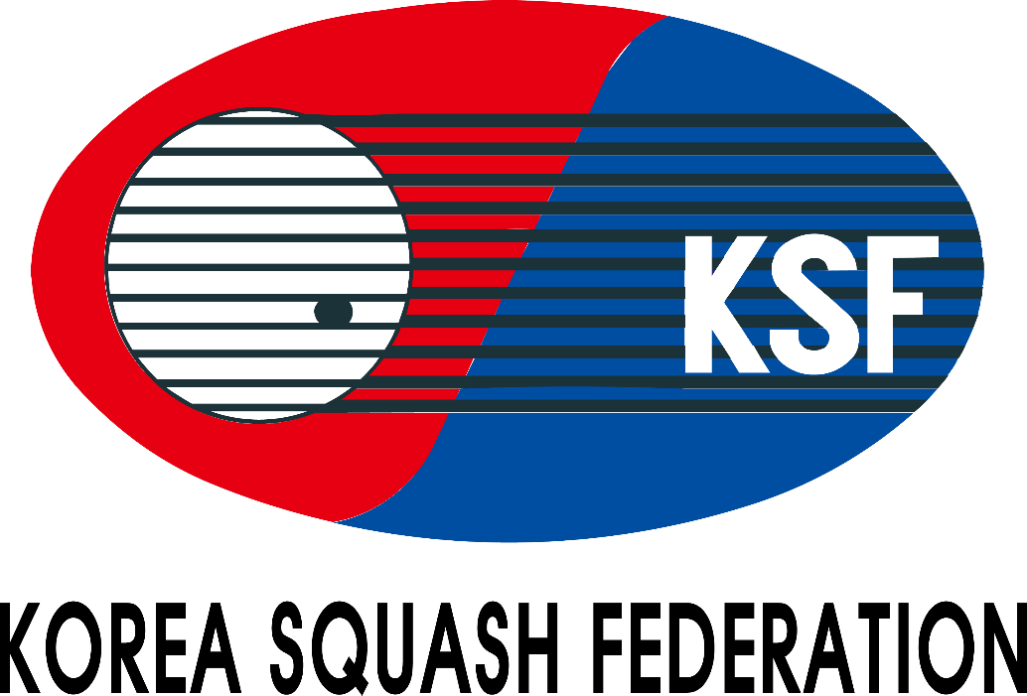

Championship Handbook
The 17th Korea Junior Open 2024(Silver)
(5 - 8 AUGUST 2024)

Venue:
Incheon Yeorumul Squash Courts

Organized by
Korea Squash Federation

Supervision by
Incheon Squash Federation

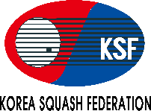
The 17th Korea Junior Open 2024
TOURNAMENT INFORMATION

VENUE
Hotel: Haborpark Hotel, Jemullyangro 271, Jung-gu, Incheon, South Korea
Stadium: Incheon Yeorumul Squash Courts (164, Yeorumul-ro, Bupyeong-gu, Incheon, Republic of Korea)
DATE
5th - 8th August 2024 / 4days
EVENTS
1. Boys under 11 Open Event 1. Girls under 11 Open Event
2. Boys under 13 Open Event 2. Girls under 13 Open Event
3. Boys under 15 Open Event 3. Girls under 15 Open Event
4. Boys under 17 Open Event 4. Girls under 17 Open Event
5. Boys under 19 Open Event 5. Girls under 19 Open Event

AGE CUT OFF DATE
* The age cut off date for the Championships is 8th August 2024
Age categories may be combined due to low entry levels at the discretion of the organizer.
If age categories are combined, participants will receive ranking points for the higher age category played.

ENTRY FEES
Official Hotel : Best Western Harbor Park Hotel(4Stars)
Address: Haborpark Jemullyangro 271, Jung-gu, Incheon, South Korea / Tel: +82-32-770-9500 / Fax: +82-32-770-9712
Check-in time: 3pm Check-out time: 11am

Package (Foreign players & Officials)
- Single Room: USD 650 per person (from 4th August 2024 check-in date to 9th August 2024 check-out date with breakfasts)5night
- Twin Room: USD 330 per person (from 4th August 2024 check-in date to 9th August 2024 check-out date with breakfasts) 5night
- Additional Nights: Single room (USD 120 per person), Twin room (USD 100 per person)
- Without Accommodation: USD 80 per person
* No shuttle services between the hotel and the venue will be provided for those who do not take up the accommodation
* No airport pickups will be provided

ELIGIBILITY
1) Registered players of the Korea Squash Federation in 2024
2) Players of member countries of the World Squash Federation
3) Resident aliens in Korea
4) Members of the squash club
* Juniors entries without SPIN number will be rejected

ENTRY SUBMISSION
1) Applications for the entry submission must be applied by players through “Forwarding the entry form” to the KSF e-mail :
koreasquash@sports.or.kr (CC: mtnet92@naver.com)
* All foreign player entries must be endorsed by their respective National Squash Federation
2) Closing Date: 25th June 2024 at Korea time 6:00pm (Late entries will not be accepted)
3) Entry Fee & Accommodation Payment : The payment must be paid in CASH to the KSF Office upon arrival.(Only USD)
4) Drawing for List of Matches : 10th July 2024 at Korea time 2:00pm, the KSF Office
* Time of the drawing may be subject to change

RULES
1) Match Play: 5 games, 11 points - PAR (Point-A-Rally) through the tournament
2) Match Rules: The Championship will be run in accordance with the ASF Championship Regulations
3) Game Balls: Dunlop XX Championship ball

TRANSPORT
1)Airport Pick-up Service
The airport pick-up service may available. It scheduled at fixed time without being adjusted to the individual schedule.
(3 times a day / pick-up schedule will be announced later)
2)Hotel-stadium shuttle bus (To be Announced)

AWARD
1) No.1/2/3 in Boys & Girls under 11, 13, 15, 17 and 19 competition – A medal
2) No.1/2 in Boys & Girls under 11, 13, 15, 17 and 19 Plate
* All players will have at least 2matchs / including plate games
* The special and classical plate games will be announced after all the matches are released. > If not duly the number of players, this game may not be held.

TOURNAMENT OFFERS
1) A championship souvenir T-shirt (including Coaches and Managers)
2) Water beverages

OTHERS
1) For more information, please contact to the Korea Squash Federation.
2) All players must comply with the KSF regulations of entry including any rules with regard to clothing
(Disqualified if violation occurs)
3) All Players must wear the T-shirt showing name of the team and the player
4) All juniors under 19 years must wear protective glasses
5) Players & Officials should check with the Embassy of the Republic of Korea to verify the need for a visa

Form A
The 17th Korea Junior Open 2024 Entry Form
Yeorumul Squash Courts (Yeorumul Squash Courts, Yeorumul-ro 164, Bupyeong-gu, Incheon, Korea)

Country:
No | Name in BLOCK LETTER |  | Date of Birth  dd/mm/yy | B/G | SPIN Number | Age  Category | ASF Ranking | Current National  Ranking / world  Ranking | T-Shirt  Size | Results / Achievements in major international championships (2023 / 24)
 | Surname | First Name
1 |  |  |  |  |  |  |  | / | Ex)S,M,L,XL...
2 |  |  |  |  |  |  |  | /
3 |  |  |  |  |  |  |  | /
4 |  |  |  |  |  |  |  | /
5 |  |  |  |  |  |  |  | /

Manager: |  |  | Coach:

Entry Fee (with accommodation / twin sharing) : |  |  |  | X USD$330 |  | = |  | USD$
Entry Fee (with accommodation / single room) : |  |  |  | X USD$650 |  | = |  | USD$
Entry Fee (without accommodation) |  |  |  | X USD$80 |  | = |  | USD$
Check-in date: |  | Check-out date: |  |  | Total : |  | USD$
*For 5 nights from 4th (check-in date) to 9th August (check-out date), including breakfast
*No shuttle services between hotel and venue will be provided for those who do not take up accommodation
*No airport pickups will be provided
Additional Room Booking
Single room = USD 120 with breakfast per person / Twin room = USD 100 with breakfast per person
Number room | Number of night | Check in date | Check out date | Total ( USD$ )
Endorsement by the National Federation
On behalf of _________________ (Name of Federation), I hereby confirm that we endorse this entry for Korea Open 2024.
Name |  | Position
Date |  | Signature |  | Federation Chop
*Please forward the completed entry form to:
Korea Squash Federation email: koreasquash@sports.or.kr by 25th June 2024.
(CC: mtnet92@naver.com)

Form B

The 17th Korea Junior Open 2024 Flight Details
Yeorumul Squash Courts (Yeorumul Squash Courts, Yeorumul-ro 164, Bupyeong-gu, Incheon, Korea)

Country:

No | Name in BLOCK LETTER |  | Arrival Date | Arrival Time | Flight no. | Departure Date | Departure Time | Flight no.
 | Surname | First Name
1
2
3
4
5
6
7
8
9
10
11
12
13
14
15
*A copy of passport must be submitted.

Name |  | Position
Date |  | Signature

*Please forward the completed entry form to:
Korea Squash Federation email: koreasquash@sports.or.kr by 25th June 2024.
(CC: mtnet92@naver.com)

Form C

The 17th Korea Junior Open 2024 Accomodation
Yeorumul Squash Courts (Yeorumul Squash Courts, Yeorumul-ro 164, Bupyeong-gu, Incheon, Korea)

HOTEL ACCOMODATION

Country / Region: ______________________________________________________
Contact Name: ________________________ E-mail: __________________________
Telephone: ___________________________ Fax: ____________________________
Single / Twin:

Room-sharing List

Room No.1 ___________________________ share with _______________________
Room No.2 ___________________________ share with _______________________
Room No.3 ___________________________ share with _______________________
Room No.4 ___________________________ share with _______________________
Room No.5 ___________________________ share with _______________________

Additional Room Booking

We wish to book the following additional hotel rooms in the Championship Hotel at a night for a single room will be USD120, twin room with be USD100 per room (with breakfast).

( ) Single room (s) for ______ nights from ___________(date) to __________(date)
( ) Twin room (s) for ______ nights from ___________(date) to __________(date)

*For 5 nights from 4th (check-in date) to 9th August (check-out date), including breakfast
*Check-in time : 3pm, Check-out time : 11am
*Please forward the completed entry form to:
Korea Squash Federation email: koreasquash@sports.or.kr by 25th June 2024.
(CC: mtnet92@naver.com)

